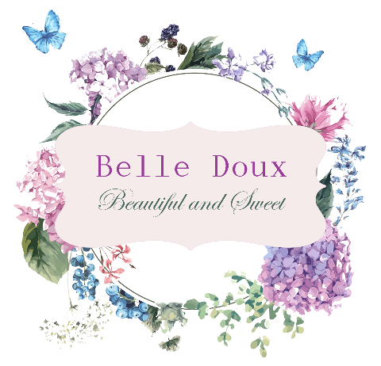

Question list
Weddings

Information
- Bride and groom details
Names:
Email:
Telephone nr:

- On-the-day contact
Name:
Telephone nr:

- Contact from venue
Name:
Email:
Telephone nr:

- Date and time

- Theme / colour scheme and accent colours

- Venue

- Guest count

Décor
Chapel
- Inside or outside?

- Vases in front of chapel?

- Down the aisle – what décor required

- Confetti bowls required?

Pre-reception
- Will there be canapés or pre-reception drinks?

- If so, require any décor for area?

- Seating plan – we have a Perspex sheet with vinyl sticker on easel

- Welcome board – we have a Perspex sheet with vinyl sticker on easel

Reception
- Table setup (rectangular / round / square)

- Amount of tables

- Guest count per table

- Separate bridal table? If so, how many guests or just bride and groom?

- Décor required on bridal table (please include inspiration pics or item reference from our catalogue)

- Décor required on ground in front of bridal table (please include inspiration pics or item reference from our catalogue)

- Décor required behind bridal table (please include inspiration pics or item reference from our catalogue)

- Table top items required per guest table (please include inspiration pics or item reference from our catalogue plus amount of each item per table)
Underplates:
Glassware:
Napkins:
Runners:
Rosegold / gold cutlery:
Candleholders:
Centerpiece items:
Vases for flowers:
Lanterns:
Table nrs:

- Cake table / gift table
Cutting set:
Cake stand:
Other décor:

- Budget

- Include set-up and breakdown?

Flowers
Information
(Flowers are chosen according to budget and best available on the day of purchase – we try to include exact flowers discussed, but may have to use alternative choices – it will, however, remain in theme and arrangements will look similar to what was discussed and agreed with bride)

- What flowers do you definitely want included

- What flowers do you not like

- Budget

Bridal party
- Bridal bouquet (please include inspiration pic)

- How many bridesmaids; what bouquets (please include inspiration pic)

- How many groomsmen; boutonnieres? (please include inspiration pic)

- How many granparents, parents; boutonnieres? (please include inspiration pic)

- How many flower girls, ring bearers; any flowers? (please include inspiration pic)

Chapel
- Flowers at front of aisle? (please include inspiration pic)

- Flowers down the aisle or on aisle chairs? (please include inspiration pic)

- Confetti?

Pre-reception
- Will there be canapés or pre-reception drinks?

- If so, require any flowers or greenery for area?

Reception
- Bridal table (please include inspiration pics)
Behind table:
On table:
In front of table:

- Guest tables (please include inspiration pics)
Centerpiece:
Other flower arrangements:

- Other special requests such as installations etc?

